Pauwels Travel Bureau Ltd.

TEL: (519) 753 2695 FAX: (519) 753 6376

[tours@pauwelstravel.com](mailto:tours@pauwelstravel.com) [www.pauwelstravel.com](http://www.pauwelstravel.com)

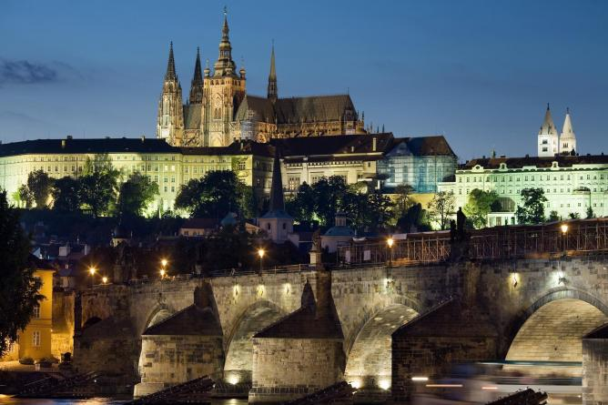

PRAGUE IN DEPTH

Friday May 9 to Saturday, May 17, 2025

Join us for an in depth look at the sights and sounds of the Czech capital through its history, architecture, monuments and food. Explore the Jewish quarter, stroll across the Charles Bridge, spend the evening in a jazz bar or take in one of the many classical performances on offer. Indulge in some cabbage, duck and dumplings washed down with a little pilsner, and journey into the Czech countryside to visit the castle of Franz Ferdinand and the UNESCO world heritage town of Kutna Hora together with our excellent, local guide who will share with you details of Czech life past and present.

Land Only Tour Cost: $2,895.00, Per person sharing double accommodation.

Single Supplement $750.00

Proposed Itinerary

Day 1 – Friday, May 9:

Arrival in Prague on your own. Transfer to the centrally located hotel, Hotel Rott (hotelrott.cz). As the rooms may not be ready yet, we will embark on a walking tour of the “Golden City” from the hotel lobby at 2PM. Points of interest include the Old Town Square, Powder Tower, the and of course the Charles Bridge. Welcome dinner in one of Prague’s many fine restaurants.

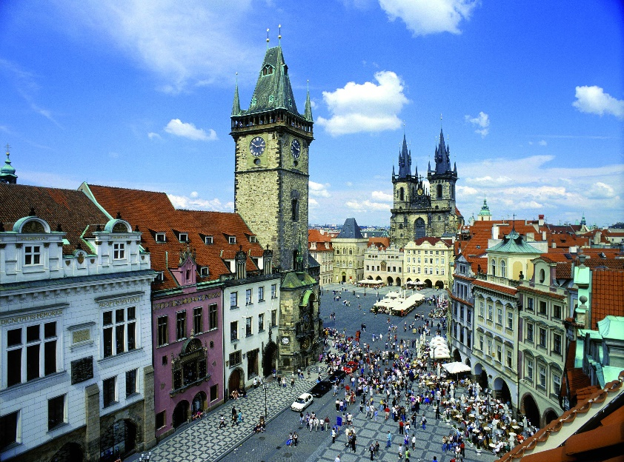

Day 2 – Saturday, May 10:

This morning you receive your transit pass and transfer by trolley to the Prague Castle district where you will have a guided tour including the Belvedere Palace, the Royal Gardens, St. Vitus Cathedral, and the Royal Place. Following the tour, we suggest you stay on to visit the interior of the palace, the Golden Lane, the National Gallery and St. George’s Basilica. A ticket that includes admission to all the castle sights is available locally and can be purchased anytime. Traditional Czech dinner tonight at a local beer hall.

Day 3 – Sunday, May 11:

Breakfast followed by a walking tour of the Jewish Quarter of Prague. Highlights include the Spanish, the Old New, and the Pinkas Synagogue. While our tour does not include visits into the Synagogues, you may wish to purchase a pass for the monuments and spend the afternoon visiting the museums and interiors. No group dinner this evening.

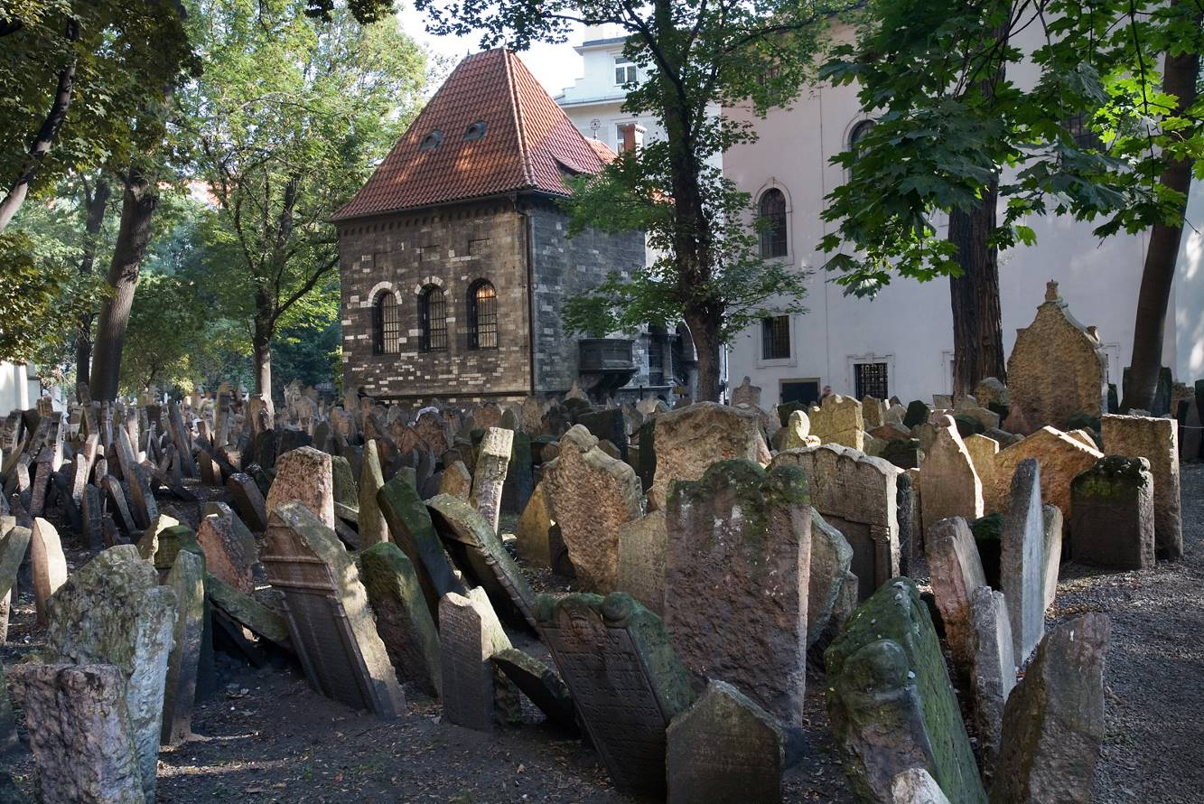Day 4 – Monday, May 12:

Full day free to pursue individual interests. In the morning your tour leader will be taking any of the participants that are interested on an excursion to Troja Palace, a beautiful chateau and former residence of Count Sternberg. Today the chateau is an art gallery dedicated mainly to 19th century Czech artists. No group dinner tonight.

*< Old Jewish cemetery.*

Day 5 – Tuesday, May 13:

Breakfast before boarding the coach and traveling to Konopiste, a 13th century castle set amid woods and parkland approximately 40 Kilometers outside of Prague. The castle was home to Franz Ferdinand at the time of his assassination in Sarajevo in June 1944. Our tour will include a visit to the interior of the castle where most of the furnishings, fittings and art objects from Franz Ferdinand’s day are in place, giving the castle an especially intimate and personal atmosphere. Dinner and evening on your own.

Day 6 – Wednesday, May 14:

Full day free to pursue individual interests. The tour leader will offer those interested an opportunity to visit Vysehrad. Here you can visit the Church of St. Peter and St. Paul as well as the Vysehrad Cemetery where you will find the aves of Dvorak and Smetana. Other points of interest are Bertramka, home of the Mozart Museum and the Mucha Museum, dedicated to Alfons Mucha, a leader in the Art Nouveau movement. Dinner on your own. This would be a perfect night to attend the ballet or opera.

Day 7 – Thursday, May 15:

Today you will enjoy an excursion to Kutna Hora, a UNESCO World Cultural Heritage site, Kutna Hora was once the second most important city in the Kingdom of Bohemia thanks to its great wealth which stemmed from its silver production and as a result rich in medieval and baroque buildings. Highlights of today’s trip include St. Barbara Cathedral and the Ossuary. Return to Prague in the mid afternoon following a group lunch at a local restaurant. Dinner on your own.

Day 8 – Friday, May 16:

Your last full day in Prague so we have left it free for last-minute sightseeing or souvenir shopping. Opportunity for cocktails at hotel and on to farewell dinner this evening. Always a bittersweet affair!

Day 9 – Saturday, May 17:

The tour ends this morning after breakfast.

WELCOME HOME!

Land Only Tour cost: $2895.00 Per person sharing double accommodation.

Single Supplement $750.00

Included in the Tour Price Are:

* Eight nights’ accommodation in a 4-star hotel based on two people sharing
* Daily breakfast, one lunch and 3 dinners
* Sightseeing as per the itinerary
* Admissions as per the itinerary
* Transportation including a public transit pass
* Fully escorted
* Gratuities to guides, drivers, and providers of services included in the tour

Not Included Are:

* Airfare. Pauwels Travel is happy to assist with air arrangements once we have a sufficient number of participants to guarantee the departure.
* Meals not shown in the itinerary
* Items of a personal nature
* Optional travel insurance. Please contact the office for rates.

**REGISTRATION FORM**

Please book seat(s) on the “Prague in Depth” tour from Friday May 9 to Saturday, May 17, 2025

I wish to book on **group flights**_____ *or* **land only** ______.

*If booking land only, please send the office a copy of your flight details.*

Please be prepared to pay a deposit of **$1000 per person and any applicable insurance premium** at time of registration. Balance is invoiced no later than 60 days prior to departure.

***We Require a Copy of Your Passport (Information Pages Only) Valid 6 Months After Tour Ends to Be Sent In With Your Registration Form.***

NAMES AND INFORMATION: Please provide names as *they appear on your passport*.

**Surname First Middle(s)**

**Date of Birth (ddmmmyyyy):**

**Surname First Middle(s)**

**Date of Birth (ddmmmyyyy):**

Address: City:

Postal Code: Phone: Cell Phone:

Email:

If traveling alone, please indicate if a **single room** is required: Yes No

If sharing, please indicate your bed preference: twin (2 beds) double (1 bed)

SPECIAL REQUIREMENTS: Please list any *dietary requests*, *allergies*, *special physical needs*, or *frequent flyer numbers* etc., below. We cannot ensure requests made 30 days or less prior to departure will be possible.

INSURANCE: Review plans and rates by clicking [here](https://www.igoinsured.com/Direct/ManulifeGlobal.aspx?ag=pauwbrt&lang=E) or calling the office. Record your quoted premium below:

All-Inclusive:______ Emergency Medical: ______ Non-Medical/Trip Cancellation ____Decline Insurance_____

PAYMENT: Cheque payable to Pauwels Travel, e-transfer to [tours@pauwelstravel.com](mailto:tours@pauwelstravel.com) or call the office to provide credit card information (Visa, Mastercard, American Express) to Sandra or Jessica.

Amount To Pay: ______________

CONSENT: “I/we agree to the terms and conditions attached to the program, have indicated our insurance choice, indicated any special requests and included payment.”

Date_______ Signature____________________________

Date_______ Signature____________________________

PAUWELS TRAVEL BUREAU LTD.

Mailing Address: 43 Condor St, Kitchener, ON, N2K0B2

Tel: 519-753-2695/1-800-380-3974 – Fax: 519753-6376 - Email: [tours@pauwelstravel.com](mailto:tours@pauwelstravel.com)

**TERMS & CONDITIONS**

RESERVATIONS AND DEPOSITS:

Reservations should be made as early as possible to ensure the departure of your choice. No reservations will be accepted without a deposit and signed registration form. Deposit amounts vary by tour and are listed in the registration form.

REFUND OF UNUSED ARRANGEMENTS:

Because the rates of Pauwels Travel Bureau Ltd. are based on group participation, no refund can be made for any tour accommodation or tour service, or tour feature not taken. If cancellation occurs while the tour is in progress, no refund can be made for the tour portion not taken. We strongly suggest that to allow for any unexpected contingencies, you purchase the all-inclusive insurance.

CANCELLATION POLICY:

Refund of deposit is made if cancellation is received in writing by Pauwels Travel Bureau Ltd. at least 91 days prior of the departure date of the tour less a $250.00 non-refundable administrative fee per person. For cancellation received in writing 90 days prior or less the following cancellation penalties apply for tour costs:

* 90 days to 61 days before departure: 35% of tour cost
* 60 to 31 days before departure: 65% of tour cost
* 30 – 0 days prior to departure: 100% of tour cost

Penalties for cancelling insurance or individual airfare may differ than the policy above. Clients are advised to review the cancellation terms for any additional services they may have purchased for the tour.

RESPONSIBILITY:

The acceptance of the initial service to be provided under the tour shall be considered an acceptance by the tour member of those conditions. We also reserve the right to decline, to accept or retain any person as a member of the tour. We reserve the right without notice, to withdraw any part or all of the tour. Factors such as airline schedule changes, hotel overbookings, inclement weather, travel warnings by the Canadian Government etc. may necessitate changes in the itinerary. There may also be other circumstances in which changes become necessary or advisable. By commencing the tour, I agree to the release and agreement as included below.

RELEASE & AGREEMENT:

By placing my deposit, submitting my registration, and commencing the tour I understand and agree to the following:

1. That all tours are delivered in conjunction with other service providers, including but not limited to travel agent and booking services, airlines, hotel and accommodation providers, transportation providers including but not limited to coach, train and ferry services, restaurant providers, and local guides. We shall not be held responsible for the failure by any person or company to render any transportation, lodging or other travel service to be provided on the tour. All hotels, transportation and other travel services are provided subject to all the terms and conditions under which they are offered to the public generally.

2. I know that tour programs include walking and may including hiking and fitness programs that have potentially hazardous activities associated with them. I should not participate prior to approval by my physician. I assume any and all other risks associated with these events included but not limited to falls, contact with other participants, the effects of the weather including high heat and/or humidity.

3. To release, indemnify and hold harmless Pauwels Travel Bureau and their affiliates (which term shall include parents, subsidiaries, officers, directors, shareholders, agents and employees of Pauwels Travel Bureau as well as Pauwels Travel themselves) (the “Released Parties”) from, and agree not to sue the Released Parties for, any claims that I may have arising from, or in connection with, any personal injury, bodily injury, mental anguish, emotional distress, physical, property or other damage that I may suffer from any cause whatsoever related in any way to my participation in this tour. Without limiting the generality of the foregoing, I release, indemnify, and hold harmless the Released Parties from, and agree not to sue them for any personal injury, bodily injury, mental anguish, emotional distress, physical, property or other damage that I may suffer from the Released Parties’ negligence other than from intentional or reckless acts by such parties. I further agree to release, indemnify and hold harmless the Released Parties from any and all acts of God, war (whether declared or undeclared), terrorist activities, incidents of politically motivated violence, illness or quarantine, strikes or government restrictions or the acts or omissions of any other agents over which the Released Parties have no direct or indirect control, including, without limitation, airlines, railways, bus companies, hotels, shipping companies, guides and sub- contracted agents or tour operators. This release also includes activities not offered that may be considered risky. I further release any Tour Directors, bus drivers or other individuals involved in my tour.

4. That the air carrier’s liability for loss of or damage to baggage or property, or for death or injury to person, is limited by their tariffs, or the Warsaw Convention, or both.

5. That Pauwels Travel Bureau shall have no liability or responsibility for me when I am absent from activities, such as visits to friends or relatives or during pre-tour/post-tour option periods if the pre-tour/post-tour period does not include the services of a Tour Director.

6. To abide by directions of my Tour Director or other leadership personnel during my tour. Failure to do so may result in my termination from tour immediately. I understand that to disobey such rules or directions are to waive the right to any refund, and that I may be sent home at my own expense. The participant and family undertake full financial responsibility for any damage caused by the participant and agree to pay his/her return home on the first available flight, should his/her behaviour be deemed detrimental to the welfare of the group.

7. To abide by all local laws when in Canada and abroad, including those concerning drugs and alcohol. (Minors must have parents’ permission to use alcohol even if the local law would otherwise permit them to.) I understand that if I abuse or disobey such laws, even unintentionally, I waive my right to a refund, and Pauwels Travel may send me home at my own expense. I also understand that, should local authorities be involved, I will be subject to the laws of the country I am visiting.

8. That if I become ill or incapacitated, Pauwels Travel and its employees, or a designated chaperone may take any action they deem necessary for my safety and well-being, including securing medical treatment (at my own expense) and transporting me home. In the event of a medical emergency, Pauwels Travel will attempt to cause appropriate treatment to be administered, and the traveller authorizes Pauwels Travel to do so. Pauwels Travel, however, makes no warranty that it will be able to cause effective (or any) emergency treatment to be administered.

9. That Pauwels Travel may use any film likenesses taken of me and any of my comments while on a tour for future publication and use my contact information for future Pauwels Travel communications.

A WORD ABOUT GROUP AIRFARES:

Please note that when booking one of our air inclusive tours, Pauwels Travel has negotiated reduced rates with the airline that we are able to confirm and lock in up to 359 days before travel. While it is wonderful to share the savings and flexibility this provides with you, our valued guests, the privilege does come with some restrictions. In some cases, it may not be possible to collect frequent flyer miles, you may not be able to check in online 24 hours before travel, or you may need to try checking in with your ticket number rather than your booking reference. Additionally, most airlines do not allow advanced seat-selection on group airfares. It is the airline’s policy, not ours, that prevents us from assigning specific seats. If a request is made, it is passed on to the airline by our staff when they submit the names to the airline 60 days prior to departure but no requests are guaranteed. Our staff will not be able to aid in advanced seat selection if the airline does not allow it on the group airfare. If a certain type of seat is indispensable to you, we suggest that you book our tour on a “land only” basis and make individual flight arrangements, in which case you may be able to get the seat of your choice; Pauwels Travel would be happy to assist you with that reservation. We will offer you the best fare available, but please note that this can only be done once a tour is a guaranteed departure because individual airfare conditions are stricter than the conditions of the group airfare rate. We thank you in advance for your kind understanding of the above!